ASSIGNMENT 2 REPORT

Name: Artur Jaxyagaliy

Group: SE-2429

# Task 1

Description:

In Task 1, I created a webpage using a two-column layout with a sidebar and main content section. The layout was built using div elements and `float/position` for structuring. The page includes a header, navbar with 4 navigation links, a sidebar with 3 items, a main content area with a heading and paragraph, and a footer.

Screenshots:

# 

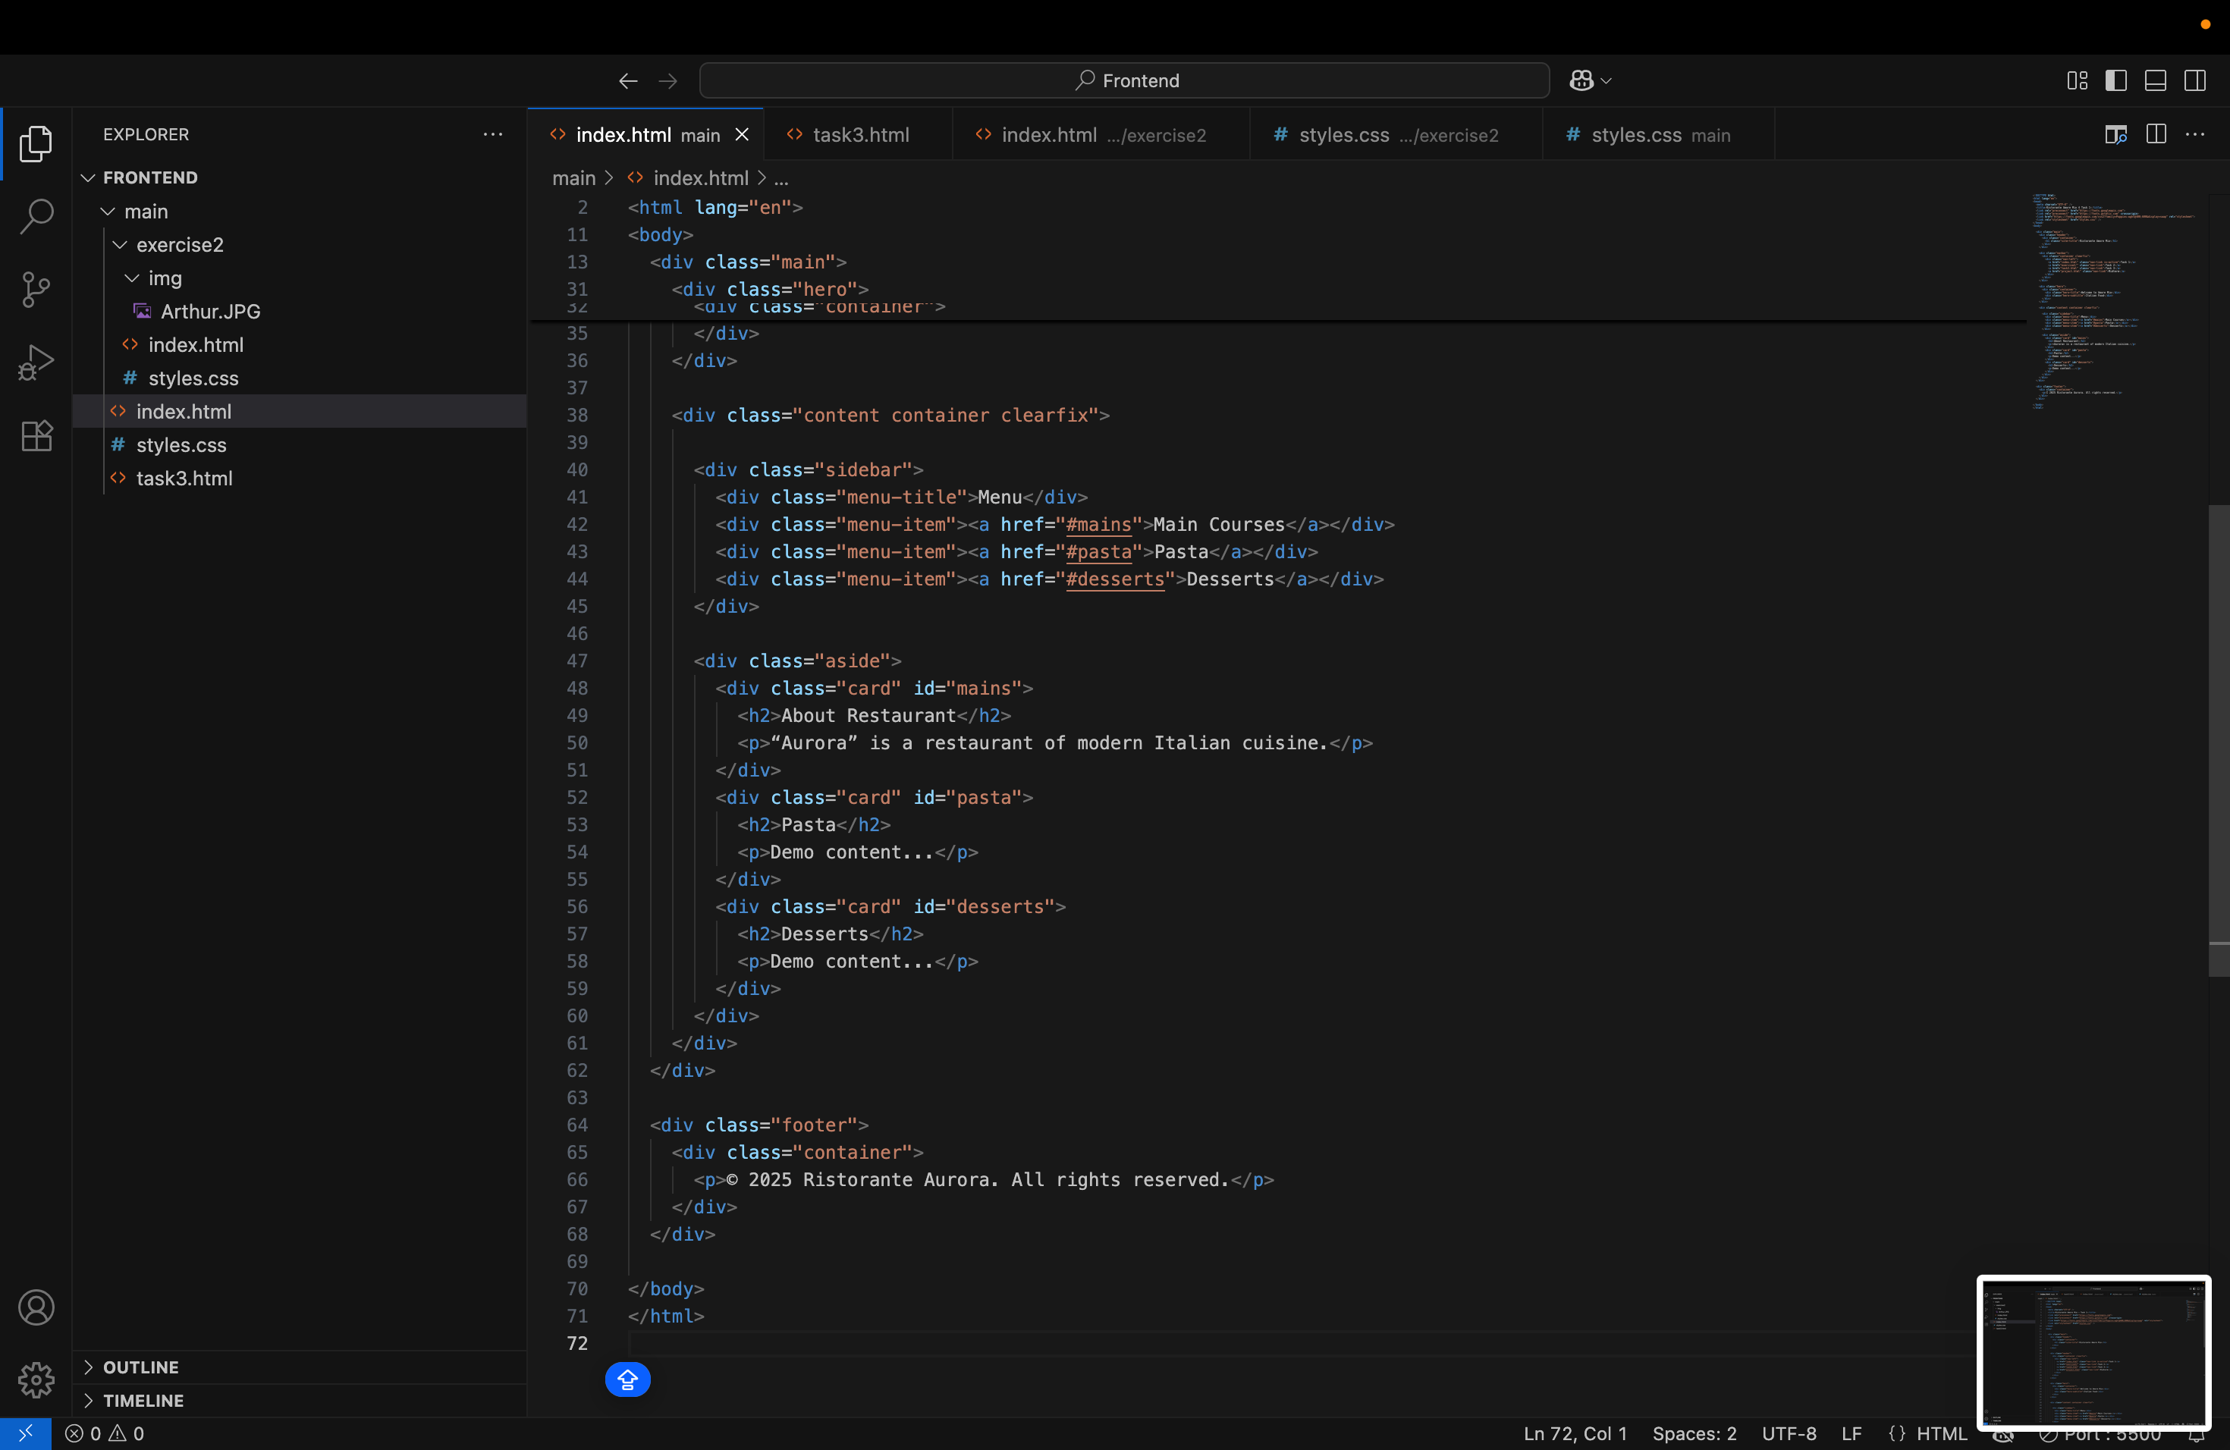

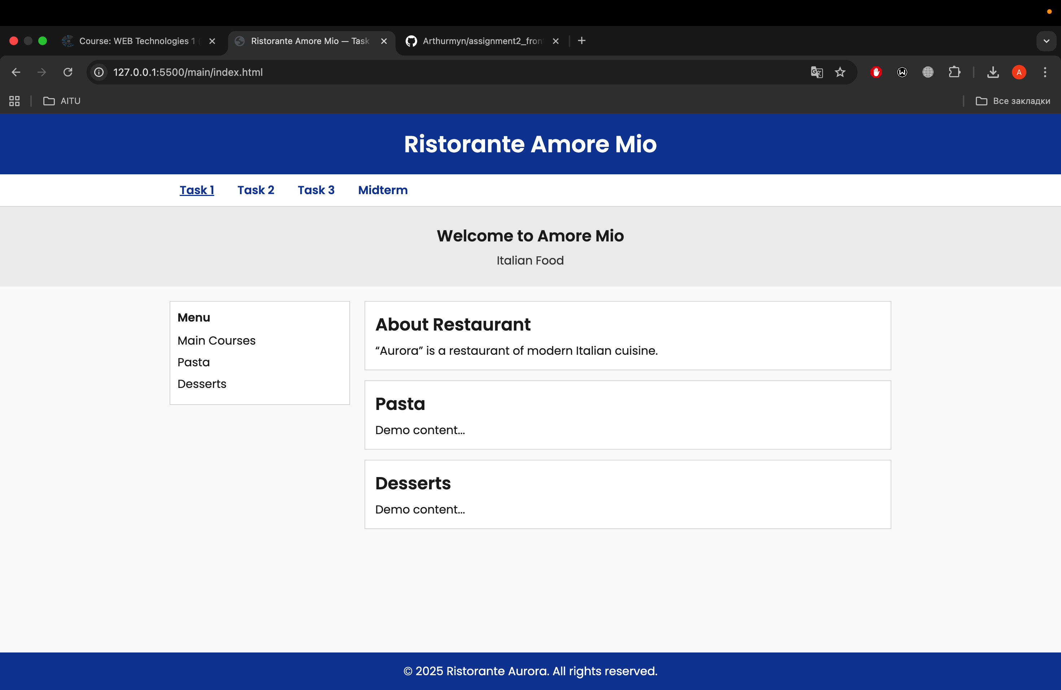

# Task 2

Description:

For Task 2, I created a Tribute Page for a Arthur. This page includes a biography section with a portrait image, an ordered list of key milestones, an unordered list of contributions, and links for further reading. The page layout follows the two-column structure from Task 1, with adjustments for images and text.

Screenshots:

# 

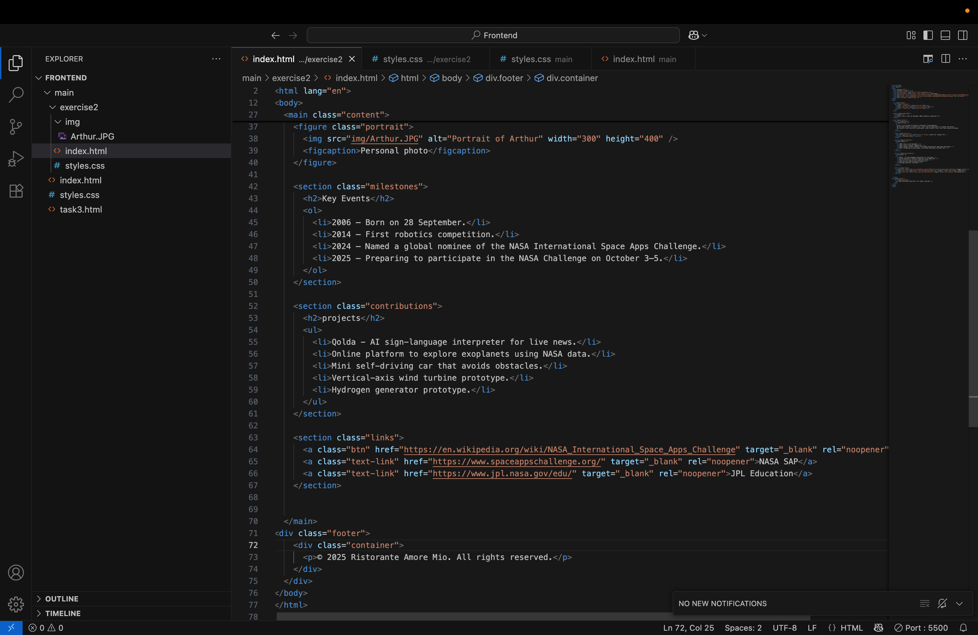

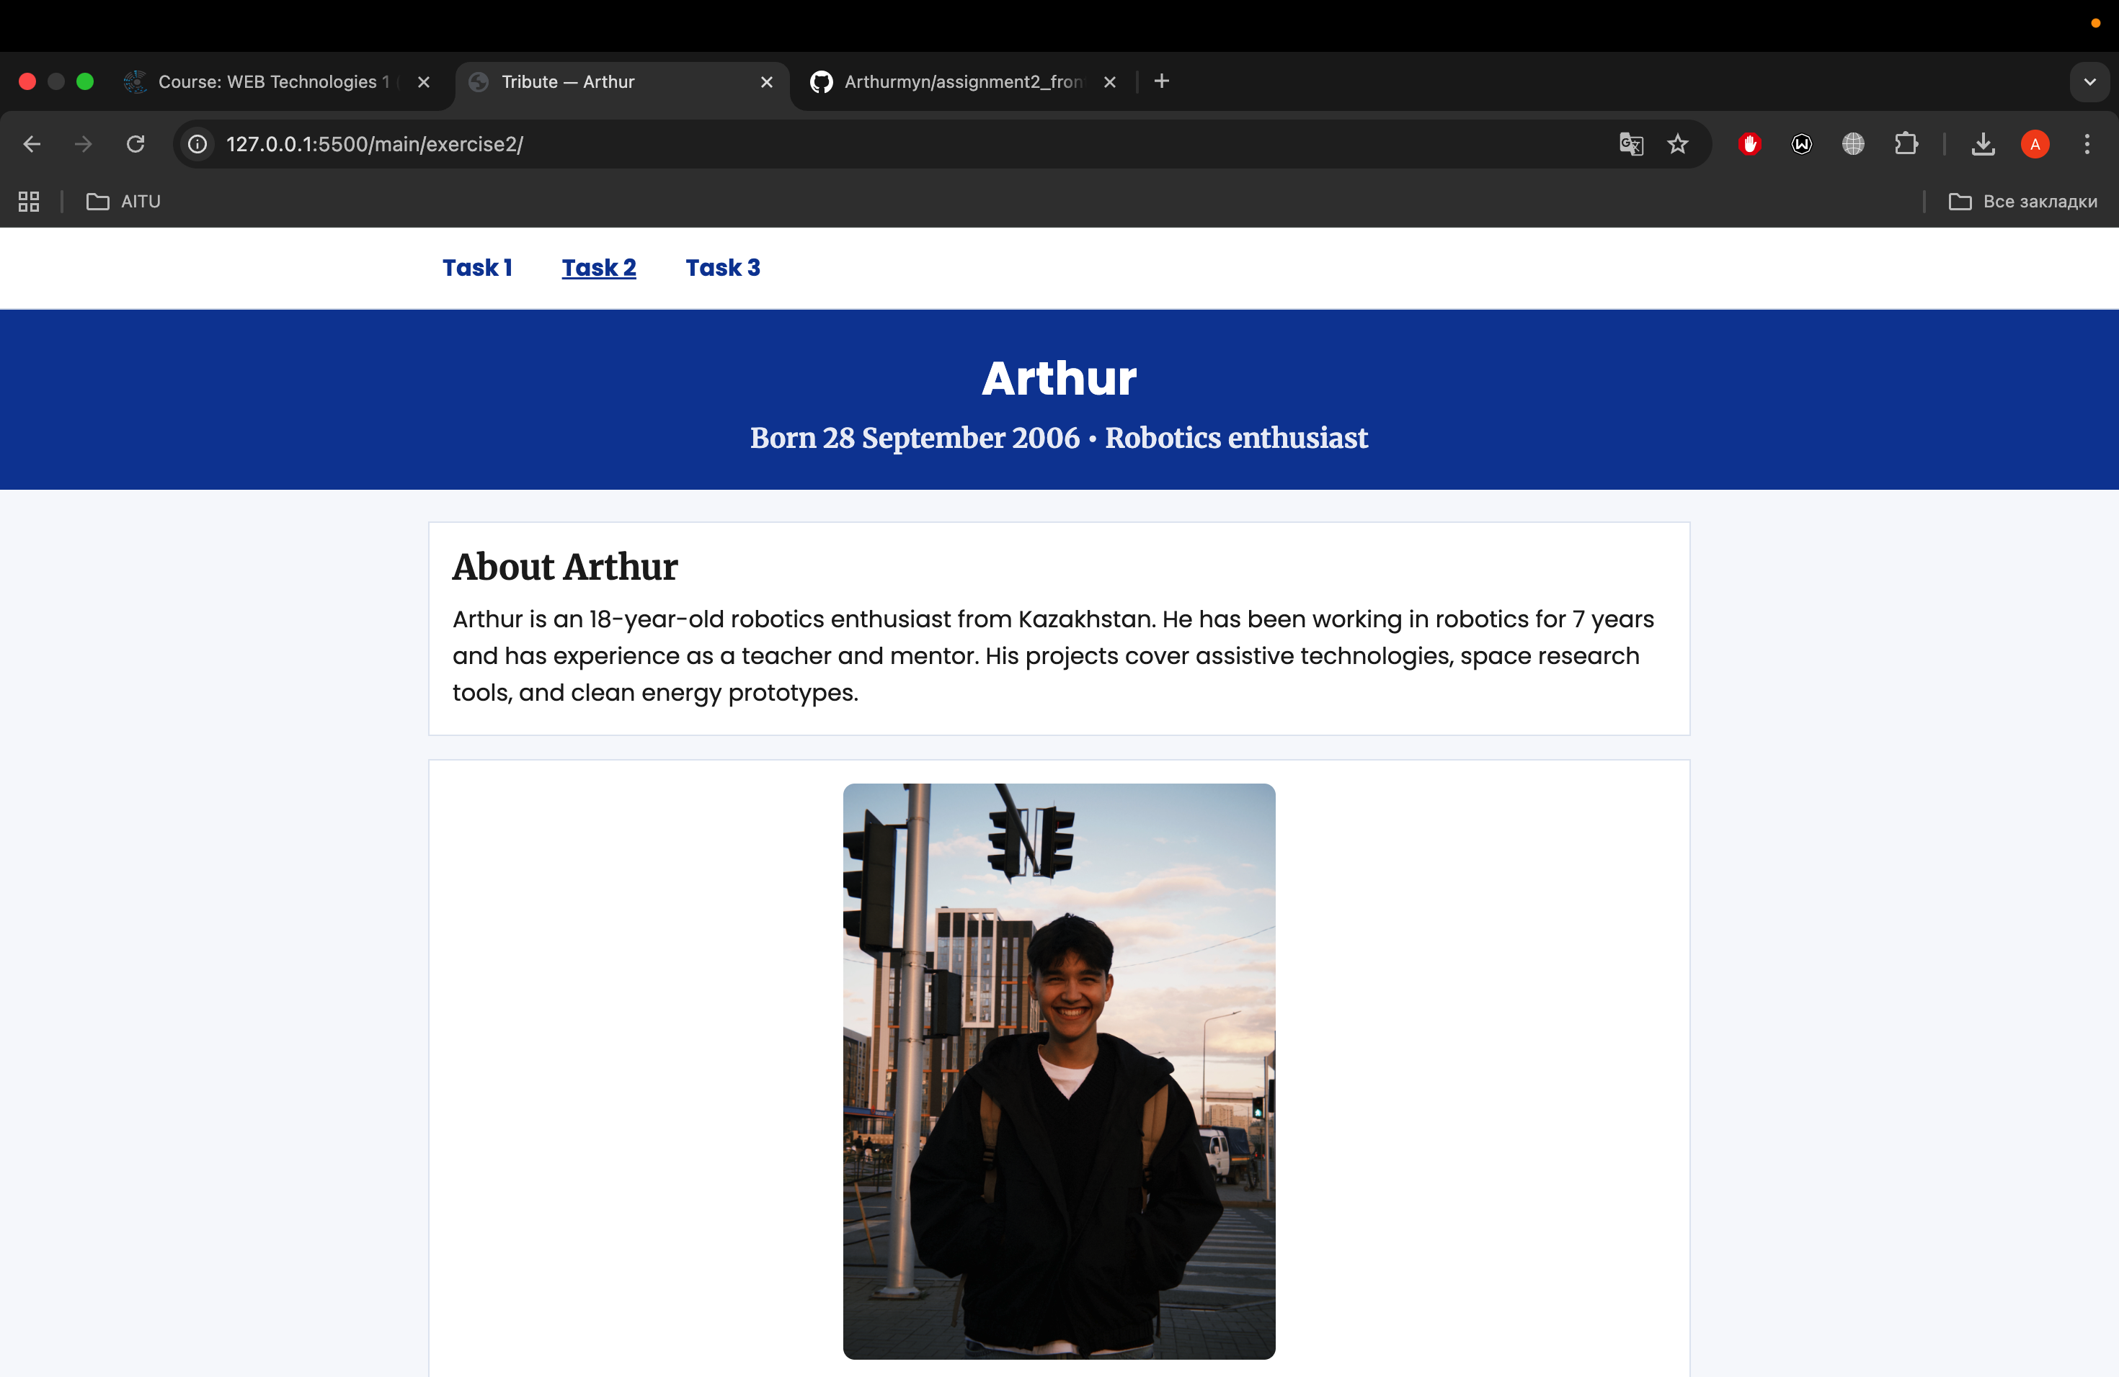

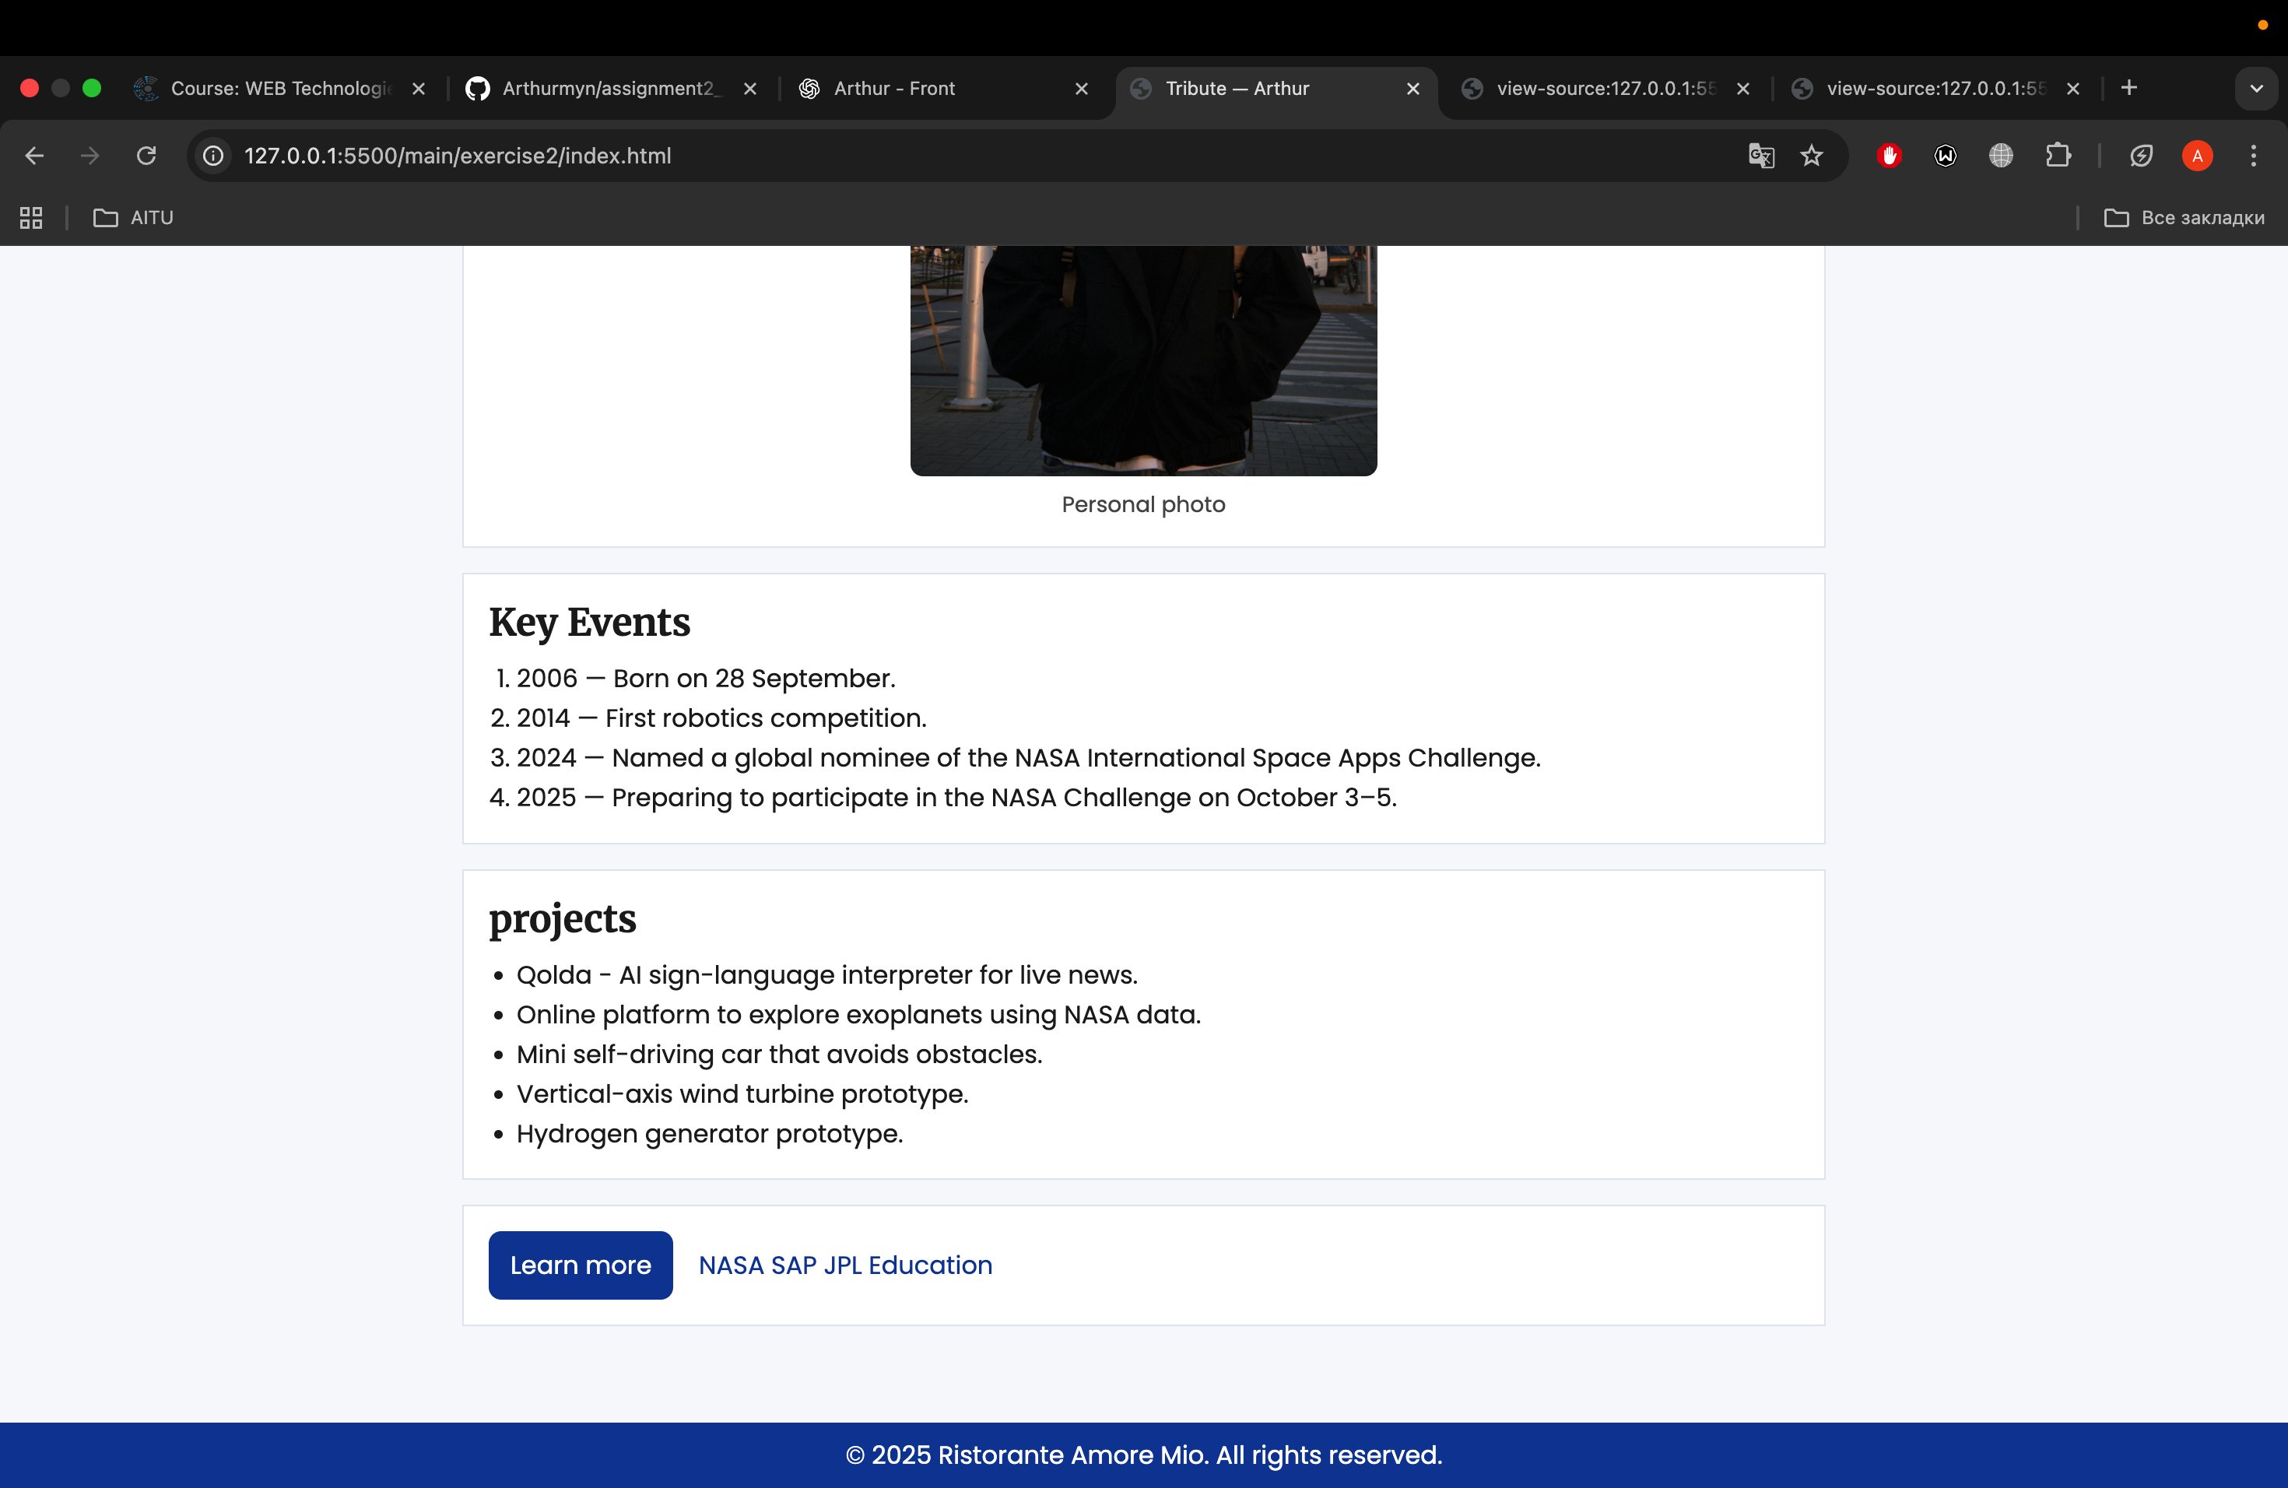

# Task 3

Description:

For Task 3, I designed a table and a feedback form. The table displays student grades with features like alternating row colors, a highlighted row, and the use of `colspan and rowspan. The form includes fields for name, email, role (select), a radio button for newsletter preference, and a comment section.

Screenshots:

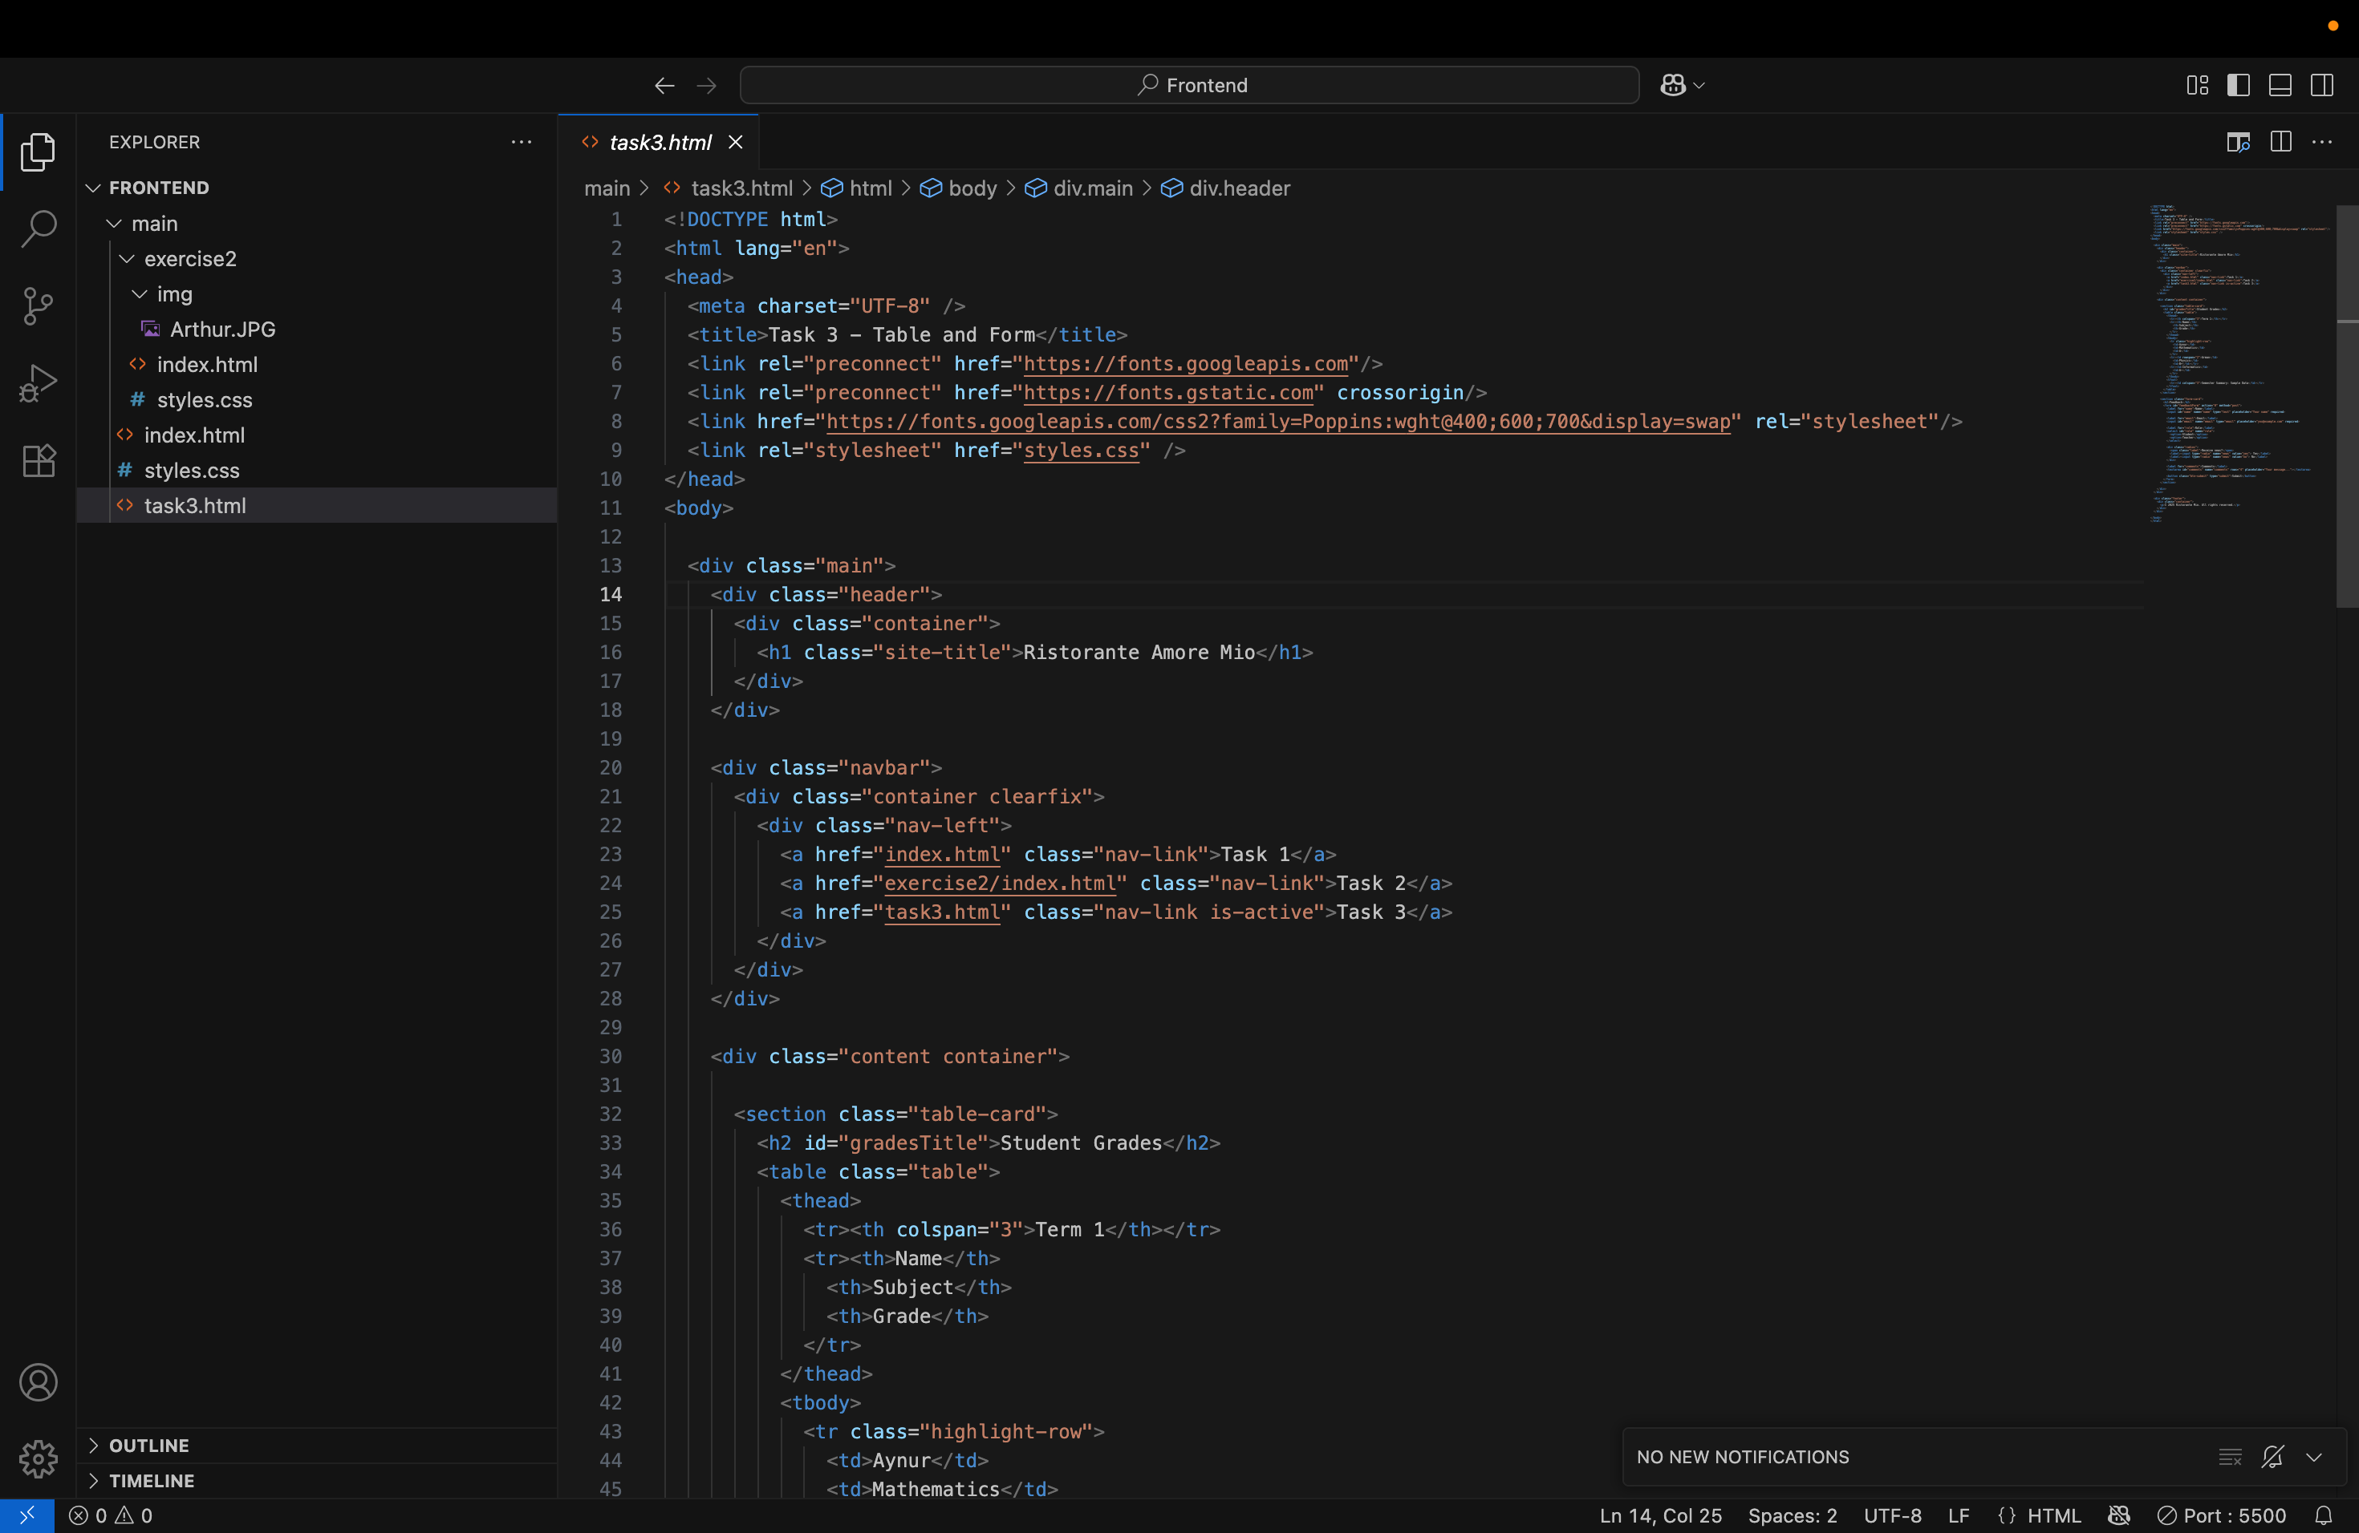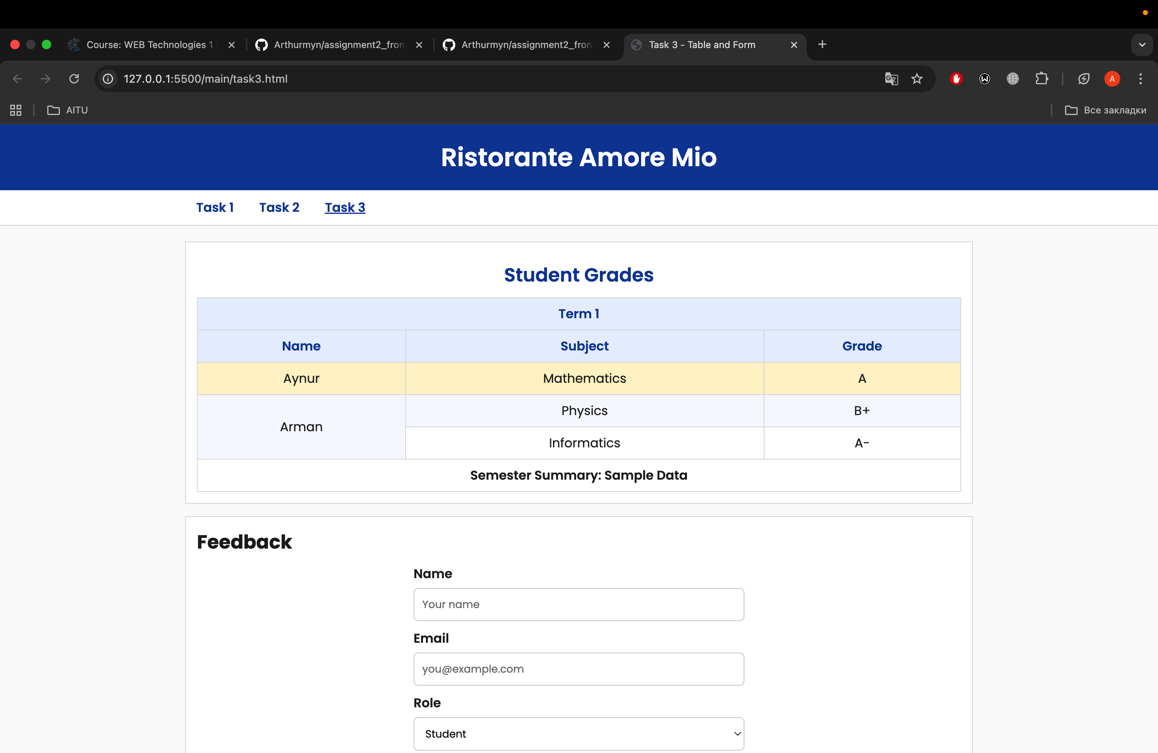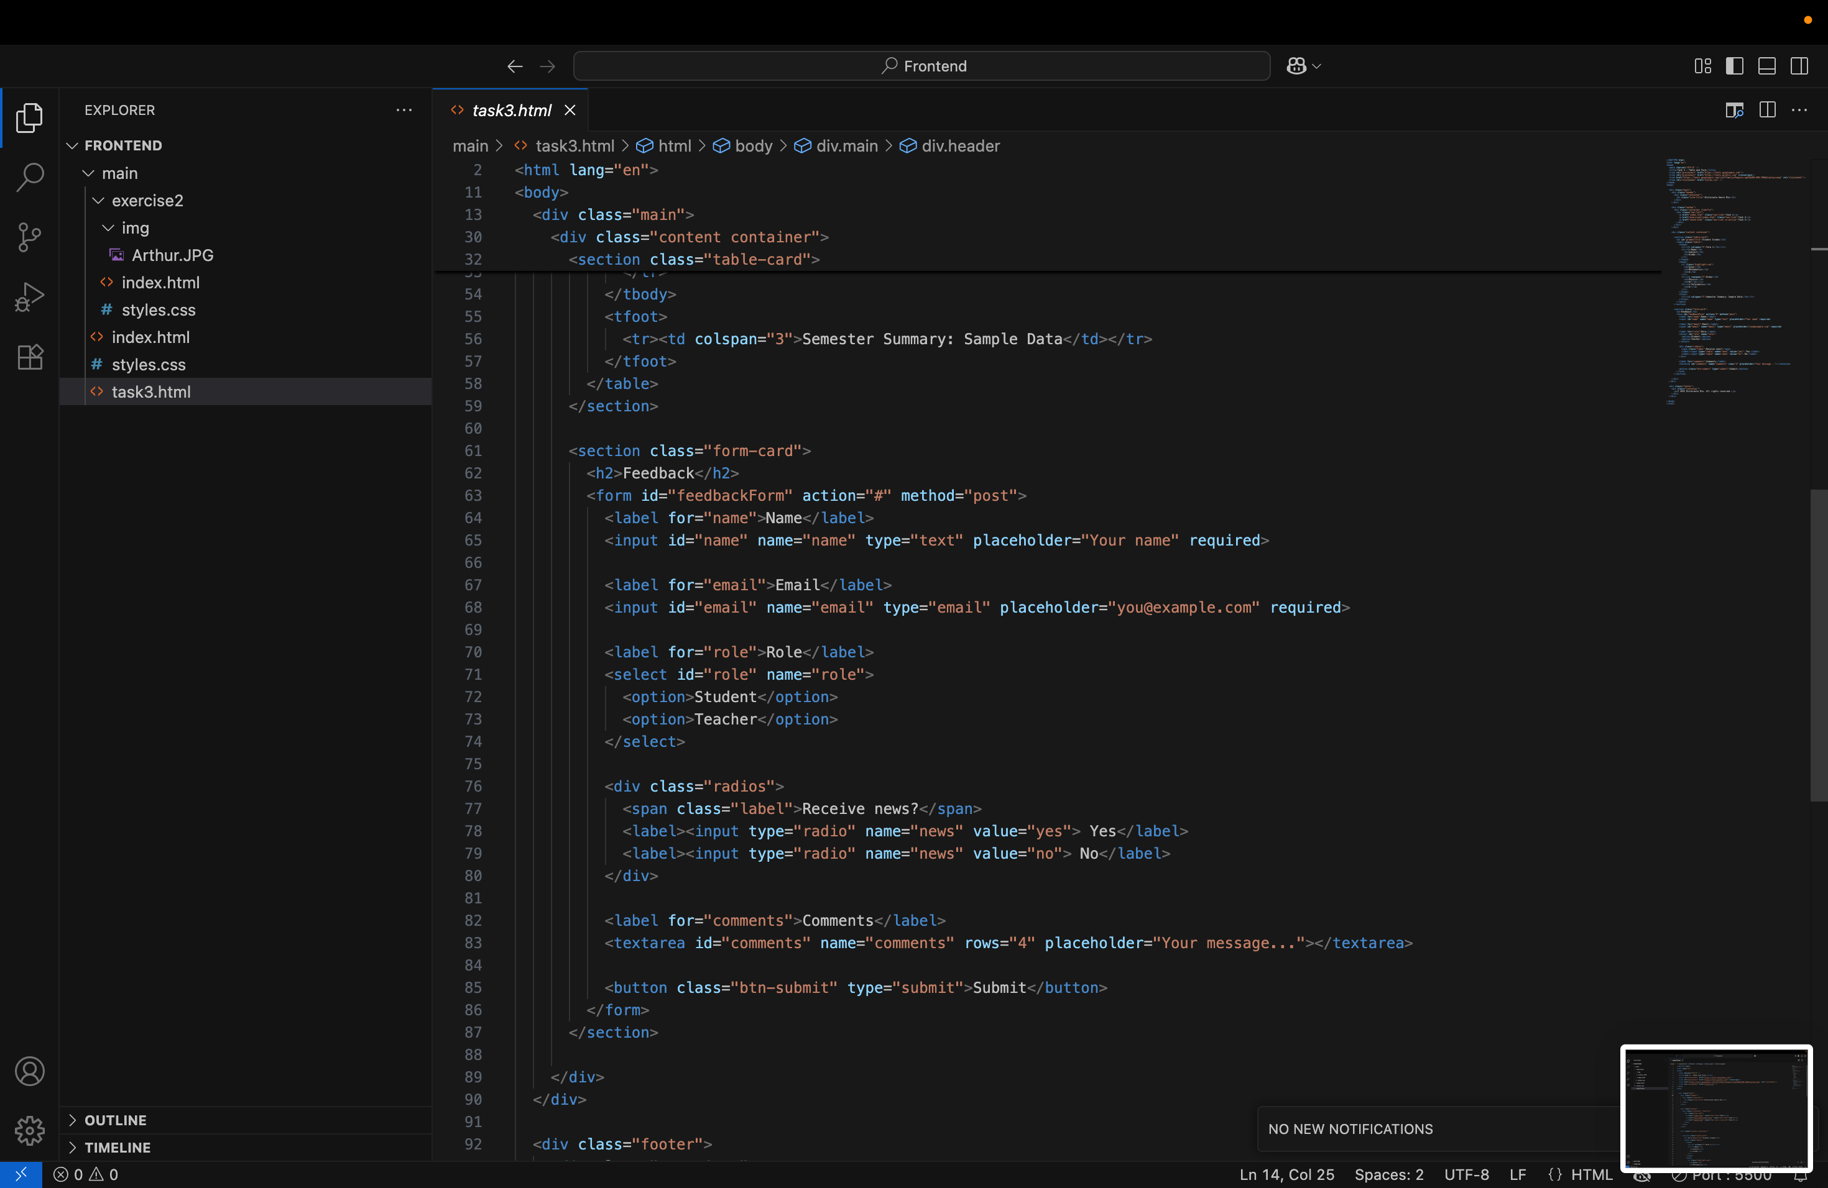



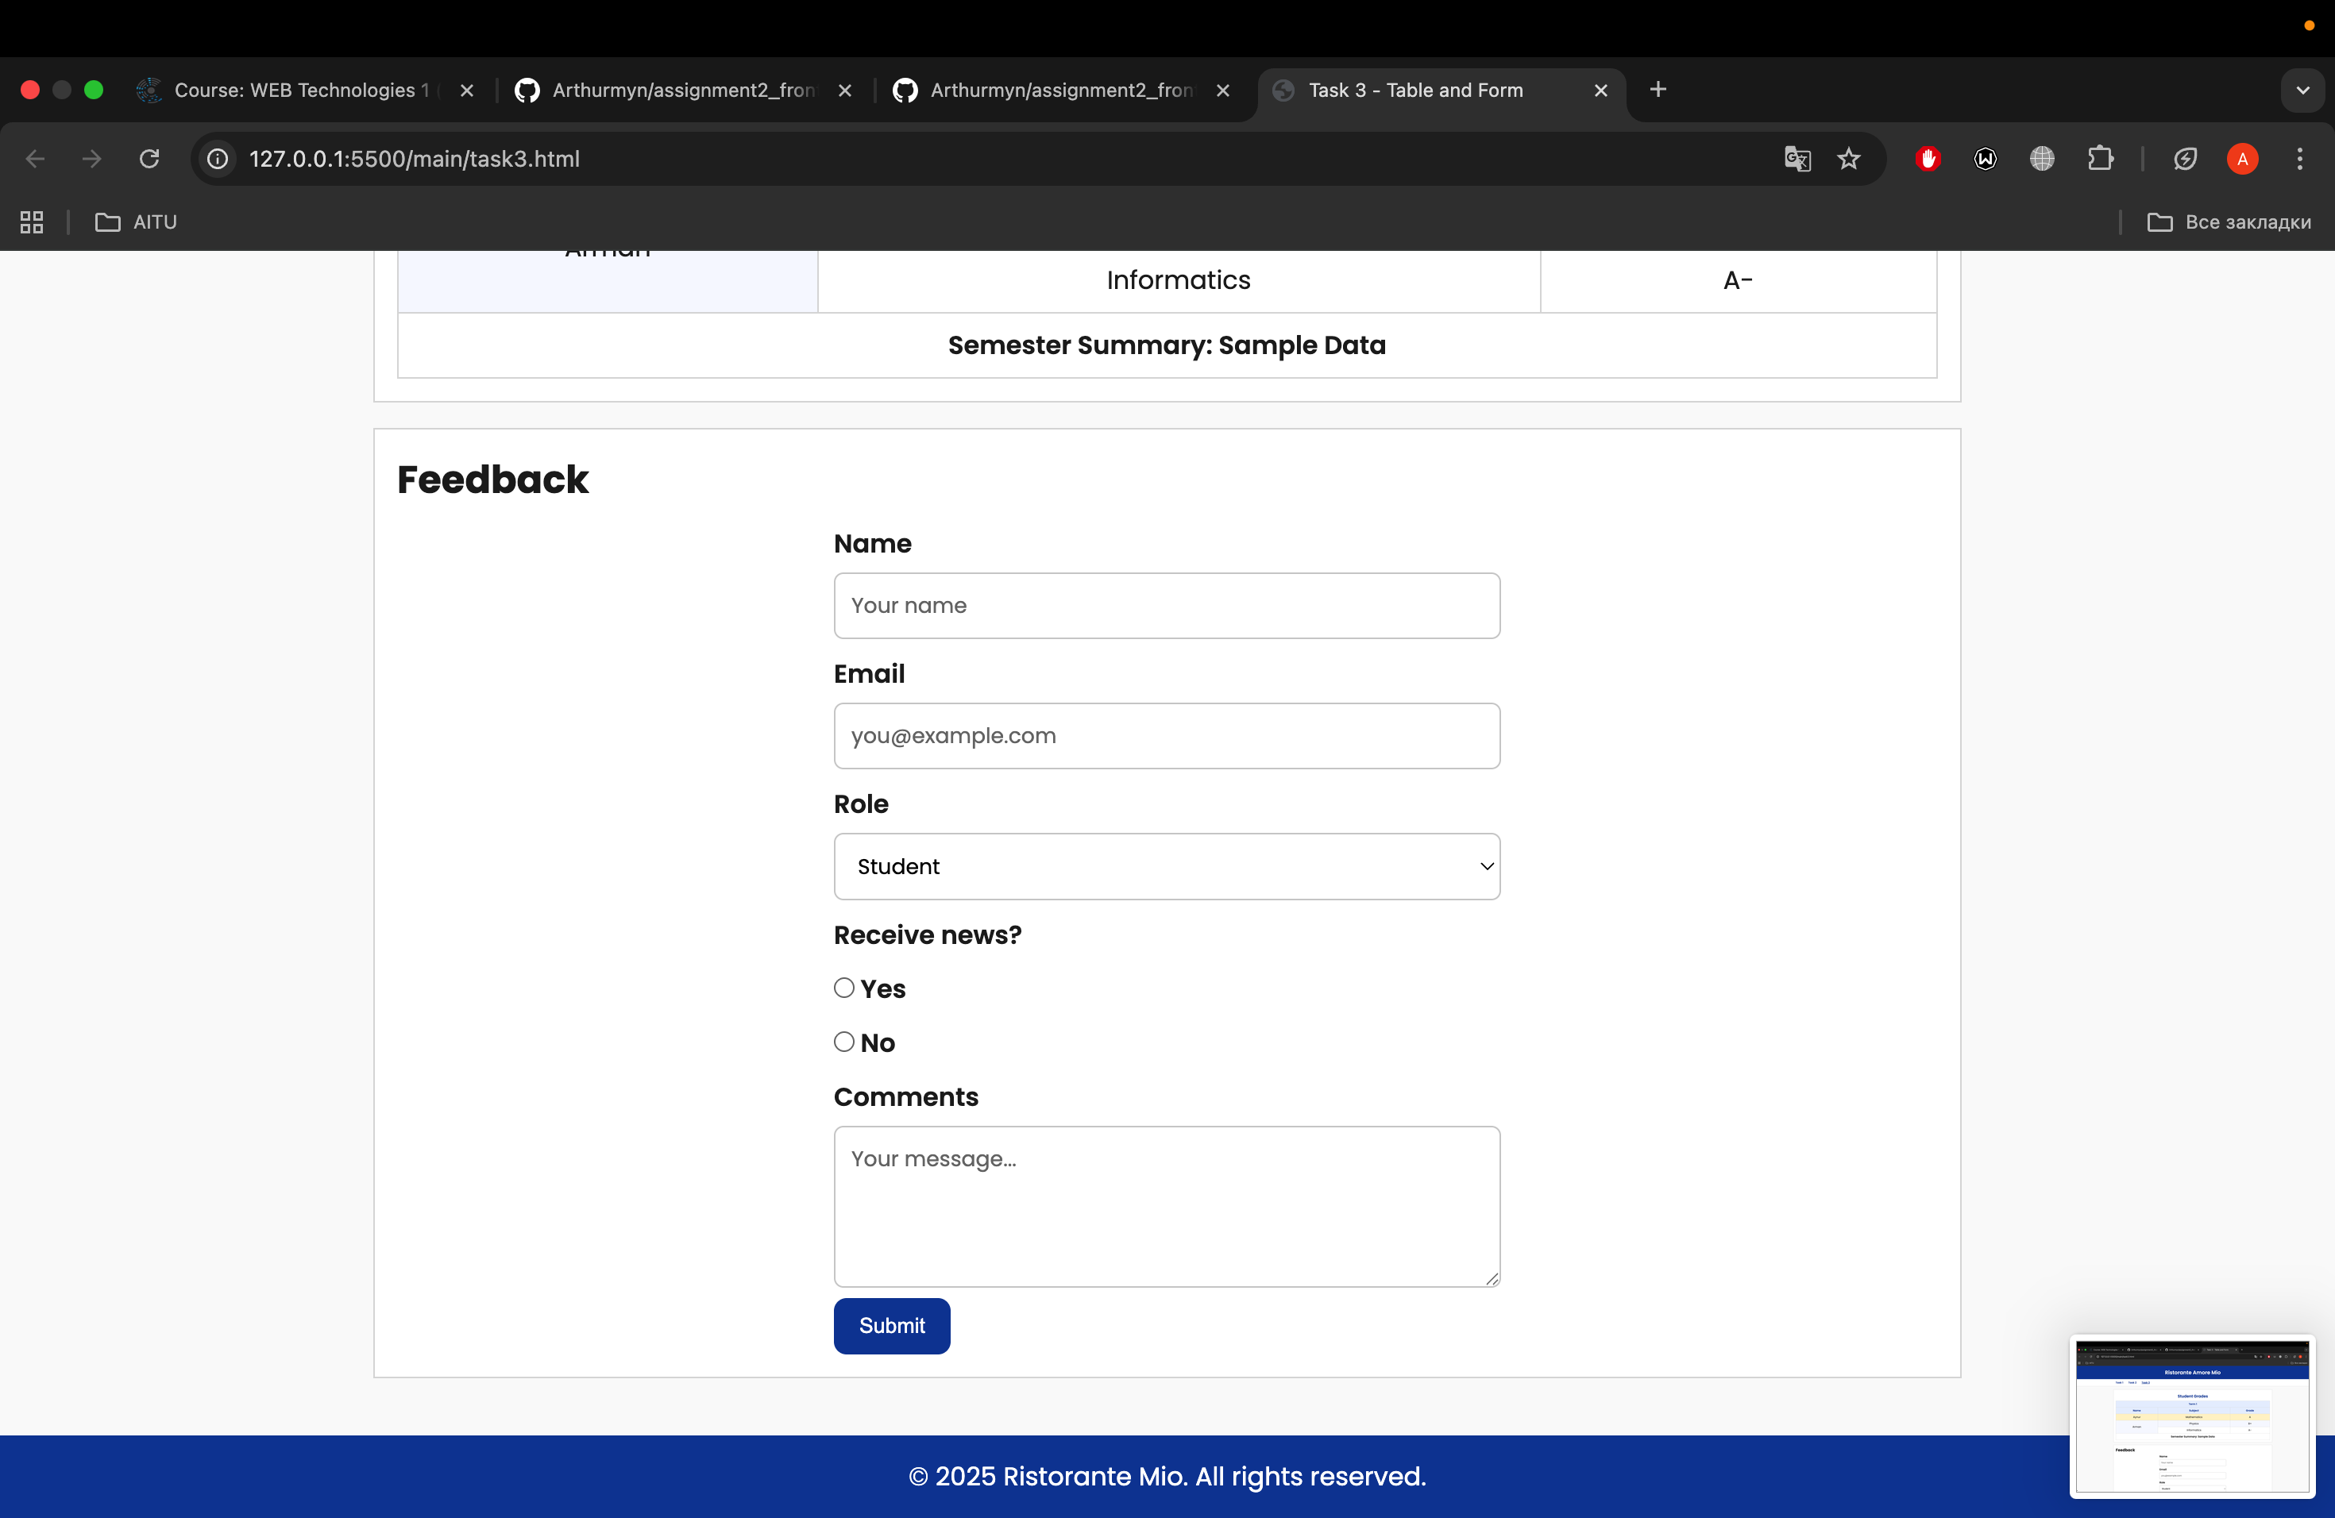

# Brief Summary of Work Process

# Planning: I decided to build the restaurant website layout (Task 1) using basic div and float/position. For Task 2, I chose to create a Tribute page. Task 3 was focused on implementing a table and form, both of which were necessary for the website's functionality.

[**https://arthurmyn.github.io/assignment2_frontend_Jaxygaliyev_Artur_se-2429_2025/**](https://arthurmyn.github.io/assignment2_frontend_Jaxygaliyev_Artur_se-2429_2025/)

https://github.com/Arthurmyn/assignment2_frontend_Jaxygaliyev_Artur_se-2429_2025